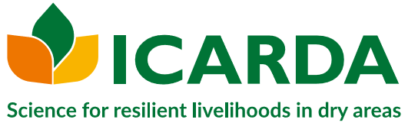
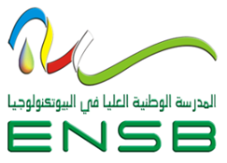
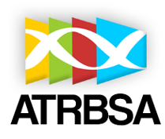
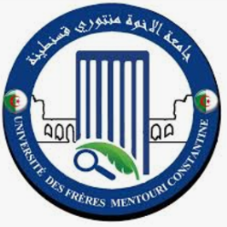
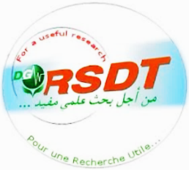
République Algérienne Démocratique et Populaire
Ministère de l’Enseignement Supérieur et de la Recherche Scientifique
Université Frères Mentouri Constantine 1

MentouriBrothersUniversityConference area
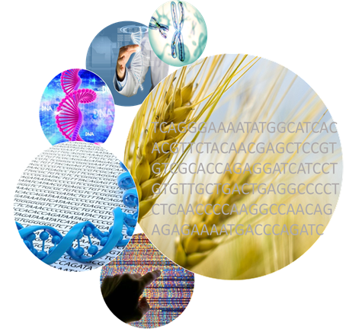
January 28-29, 2019
UFMC1-Constantine, Algeria

www.umc.edu.dz / email:sigsb2019@gmail.com
International Seminar
GENOME AND
WHEAT SEQUENCING
First Call for communication
Themes:

Genomes of wheatsand related species;

Technologies and genomics new approaches;

In silico analysis and wheat genome sequencing.

Preamble

Wheat is a staple food that provides fifth of the consumed calories worldwide; it feeds more than one third of the world's human population. It has an unusually complex genome, partly because of its long period of domestication. Wheat production must be increased by 1.6% per year to meet the demand of a global population that will reach approximately 9.6 billion people by 2050.

2018 has been marked by a remarkable scientific achievement, which is the annotation and description of the high-quality reference sequence of bread wheat. This work is the result of more than 1800 scientists from 530 research institutions from 62 countries. It has been announced by the International Consortium for Wheat Genome Sequencing (IWGSC) in September 2017 and published in the journal “Science” on August 17, 2018.

This scientific tool will provide valuable opportunities to address breeding challenges with faster identification of genes controlling traits of agronomic interest, and will facilitate selection of markers associated with relevant traits, such as tolerance and resistance to abiotic and biotic stresses.

Today, with published sequences, it will be possible for the scientific community to undertake research on homologous genes in other species in order to be used in breeding programs.

This huge work performed on bread wheat genome will without doubt revolutionize many areas of biology by changing experimental strategies and by putting forward new tools for diagnosis and varietal selection.

Objectives

Due to this great scientific work achievement “Wheat genome sequencing” this seminar is organized to:

- Enlighten local and international scientists about the issues of this accomplishment;
- Bring together senior and junior researchers to share and exchange know and know-how on cereal genomics and sequencing;
- Open possibilities of initiating and strengthening collaborations on common projects of interest between institutions involved in this field;

To achieve these objectives, several national and international institutions (DGRSDT , UFMC1, ATRBSA, ENSB, ICARDA, INRAA, ITGC, CRBT, Sétif1 University, ATRSNV, ENSA, Selçuk University KONYA Turkey, CIMMYT Mexico, CBS Sfax Tunisia, Sapienza University Rome Italy, CIRAD, IRD Montpellier France, INRA Clermont Ferrand France) in collaboration with the GBBV laboratory (Génétique Biochimie et Biotechnologie Végétale) of the UFMC1, have defined a common approach to exchange information about the work done on wheat, and that by organizing a scientific meeting which will be held on 28 and 29 January at UFMC1.

President of the seminar

Pr., DJEKOUNAbdelhamid(Rector of UFMC1, Algeria)

Scientific Committee

Pr., BOUTEKRABTLynda (Director of ATRBSA, Algeria)
Pr., KHELIFIDouadi(Director of ENSB Constantine,Algeria)
Pr., YKHLEF Nadia (Vice rector UFMC1, Algeria)
Dr., BENBELKACEMAbdelkader(Director Rech, INRAA, Algeria)
Pr., AMMAR Karim (CIMMYT, Mexico)
Pr., AMRI Ahmed (ICARDA, Morocco)
Pr., BOUZERZOURHamenna (Sétif 1 Univ., Algeria)
Dr., GHERBIHassen (CIRAD, IRD, Montpelier, France)
Pr., HAFSI Miloud (Sétif 1 Univ., Algeria)
Pr., E HAKKIErdogan. (Selçuk, Univ., Konya, Turkey)
Pr., KHELIFI Lakhdar (ENSA, Algeria)
Pr., UDUPA Sripada (ICARDA, Morocco)

Organizing Committee

Pr., YKHLEF Nadia (Vice rector UFMC1, Algeria)
Dr., BENBELKACEMAbdelkader(Director Rech, INRAA, Algeria)
Pr., HAMIDECHI Med Abdelhafid (UFMC1. Algeria)
Pr., DEHIMET Laid (Dean SNV., UFMC1. Algeria)
Dr., BOUSBA Ratiba (MCA., UFMC1., Algeria)
Dr., BELLIL Ines (MCA., UFMC1., Algeria)
Dr., HAMLA Chourouk (MCB. UFMC1., Algeria)
Mrs., KELLOUKamel (MAA., UFMC1., Algeria)
Miss., MOUELLEFAdra (MAA., UFMC1., Algeria)
Mrs., BELBEKRI Med Nadir (GBBV, UFMC1., Algeria)
Mme., BOULDJEDJRyma (GBBV, UFMC1., Algeria)
Dr.,BECILA Samira (ATRBSA., Algeria)
Dr., BANI Moustafa (ENSB., Algeria)

